Devon & Cornwall Horse Watch | Summer  2022

Welcome to the quarterly Devon and Cornwall Horse Watch newsletter, which gives you a glimpse into the work undertaken through the partnership between Devon and Cornwall Community Watch Association and Devon and Cornwall Police to provide crime prevention and community support for all horse owners and riders, as well as stable/livery/yard owners and users across both counties.
If there is any information, guidance, or a topic you would like us to cover then just let us know!

Happy reading….

This issue:
- Crime round-up.
- The County Shows
- Livestock Casualty Reduction Project.
- The Rural Survey

JOIN HORSE WATCH!
One of our aims is to continue to increase the reach of the Horse Watch scheme and also the sign-up to DC Alert messaging. These are both free of charge to join.
As a HW member you will get regular newsletters, crime prevention advice, and importantly, a yellow yard sign! We can also undertake tack marking by arrangement.
There is also a dedicated Facebook page for this Horse Watch group that has updates, news, events and also copies of the newsletters.
Find us here:
Devon & Cornwall Horse Watch

You can find out more about the DC alert scheme and sign up for the messages here:
https://alerts.dc.police.uk

Equine Related Incidents and Crime.

Below is a summary of equine crime reported between Jan-July 2022. These figures exclude incidents where there was a dispute over ownership of animals, equipment, or yard rental, bill payment etc. The ‘dogs’ category refers to incidents where horses/riders have been chased by dogs. The theft of specific ‘horse trailers’ is not included in this table as when trailer thefts are recorded, the type of trailer stolen could be listed as agricultural or equine or just by brand/type. It is therefore hard to quantify ‘horse trailers’ specifically. In the same period, there were 30 trailer thefts throughout Devon & Cornwall.
Nationally, in terms of trailers (all types), there has been a 69% increase in reports of theft. This is due to a worldwide shortage of parts which is causing delays in the production of new stock, therefore, fuelling the secondhand market and ultimately thefts of these items.
(Please see below for tips and advice on trailer security.)

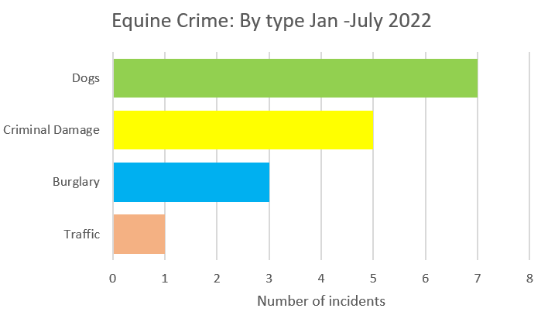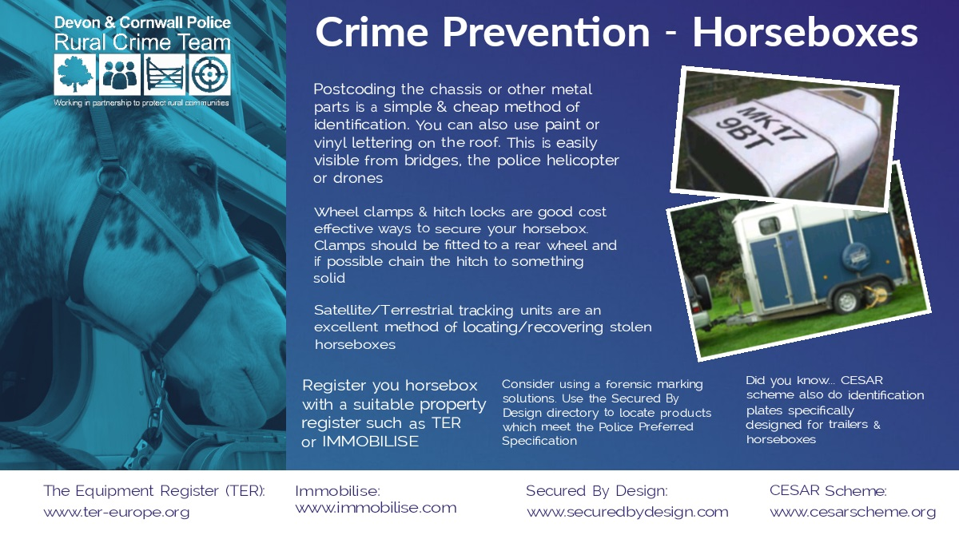

Livestock Casualty Reduction Project - Dartmoor
More than 200 animals on Dartmoor are being given reflective neckbands to make them more visible to vehicles and help prevent road traffic collisions.
The bands will be issued to famers of 80 Dartmoor Ponies and 150 cattle following a successful funding bid to the Vision Zero South West Road Safety partnership.
The idea came from Dartmoor Forest Parish Council who say collisions and animal deaths have been a major concern for several years.
They successfully bid for £6,306 from the Vision Zero South West ‘Call For Ideas’ scheme which will pay for neckbands for animals specifically along the B3212 road from Peek Hill to Princetown.
The scheme was officially launched at a special event on Friday, June 24 at 10am outside the Princetown Visitors Centre.
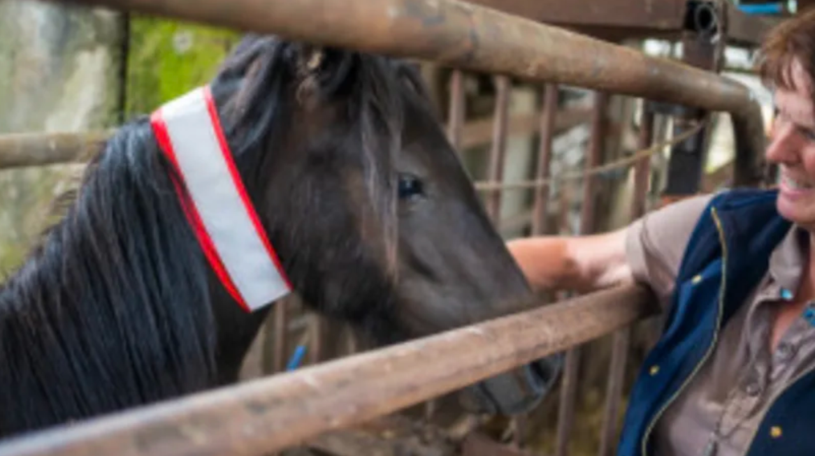

Watch the film here:

https://youtu.be/WUMTvp9x8W8

Read the full story here:

Dartmoor ponies and cows given reflective neckbands to prevent car collisions - vision-zero (visionzerosouthwest.co.uk)

A moorland pony fitted with one of the special reflective, hi-viz, elasticated collars.

Engagement: The County Shows

Members of the Devon & Cornwall Police Rural Affairs Team were at both the Royal Cornwall Show and Devon County Show to kick off the summer season of rural engagement. As well as linking in with partner agencies and holding drop-in sessions at various locations, we were able to offer sign-ups to the Farm and Horse Watch Schemes and DC Alert.
It was good to speak with so many people at both venues.

At the Devon County Show, we were lucky enough to be able to work with the Mounted Section from Avon &Somerset Police. Ring demonstrations were conducted covering the changes in the Highway Code, how to share road space safely and how to pass horses correctly – this is a project called Operation Close Pass. There was also an interesting insight into how the police horses are trained with demonstrations using flags, balls, banners, and noise. The police horses were impeccably behaved, despite the thunder and lightning that descended during the afternoon performance!

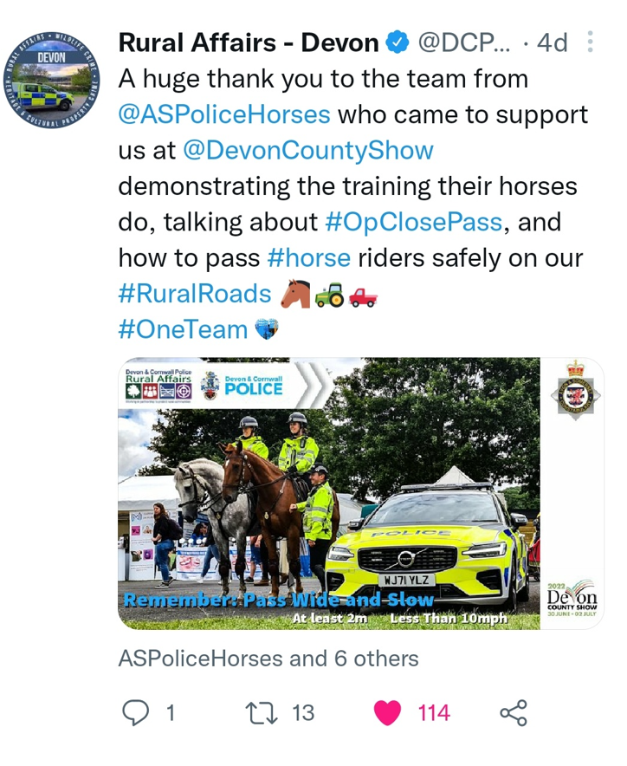

If you would like to see the demonstration, it is here:

https://vimeo.com/725812284/1cccbb9fc6

Farming Survey…

Devon & Cornwall Police are undertaking a survey of farmers and landowners as part of a research project with the Universities of Plymouth and Winchester. It aims to examine farmers' experiences of crime and policing and is being funded by the Seale Hayne Educational Trust. We are hoping to reach as many people as possible across the South West with the project’s aims being to map the nature and location of crime in rural places; analyse the impact of crime, and fear of crime, on farming; and examine ways to evaluate and improve farm security. The information from the report compiled from this survey will be used to inform and shape future Devon and Cornwall Police approaches to engaging with and policing rural communities.
For the information taken from the survey to be effective we need as many replies as possible. If you are a landowner, smallholder, farmer etc, could you please help us by completing the attached survey?
The survey will be open for about two months.

Please find attached a flyer for the survey and a separate link here below:

e hoping to reach as many people as possible across the

https://plymouth.onlinesurveys.ac.uk/rural-crime-survey-final

Your Horse Watch Team

Devon & Cornwall Police Rural Affairs Team | PC 5036 Kerry WHITTING covering Devon  PCSO 30381 Jennifer HOSKING covering Cornwall
Devon and Cornwall Community Watch Association | Julie Dowton, Chair of DaCCWA

As a team, we aim to increase the membership of Horse Watch, and continue to drive down crime by promoting sound prevention advice.

You can contact us via 101 or by emailing: horsewatch@devonandcornwall.pnn.police.uk We are also on Facebook and Twitter offering regular updates and letting you know the events we will be attending:

Facebook Devon and Cornwall Horse Watch
Twitter @DCPoliceRural_D or C (for Cornwall) for all rural matters

If you have an incident to report, do not hesitate to ring the Police on 101 for a non-emergency or 999 if you see a crime taking place.

You can also report using by email on 101@devonandcornwall.pnn.police.uk

Devon and Cornwall Community Watch Association is the umbrella organisation for all community watches across Devon, Cornwall and the Isles of Scilly. In addition to Horse Watch, DaCCWA runs a number of other community watches including Neighbourhood Watch, Farm Watch and Boat Watch.
You can contact us at: DaCCWA@devonandcornwall.pnn.police.uk CCTV and
Signing up to DC Alert
You are receiving this message due to selecting an interest in ‘Horse Watch’ or ‘Farm Watch’.
You can sign into Devon and Cornwall Alert to change your preferences.
Please share this message with anyone you feel would benefit from it; they can sign up to receive it directly from also visiting Devon and Cornwall Alert

